Multi-Point Collinearity

Definition
# Source: AI Source: Provided by: [Data Path: Persons Table -> ID Column: 1, Name_En Column: Motasem Essam] -> From: [ChatGPT] on [7/25/2026]
Multi-Point Collinearity is a type of collinearity in which three or more distinct points lie on the same straight line.
For a set of points
$$P_{1},P_{2},P_{3},…,P_{n}$$
the points are multi-point collinear if there exists a single straight line $l$such that:
$$P_{1},P_{2},P_{3},…,P_{n}∈l$$
where:
$$n≥3$$
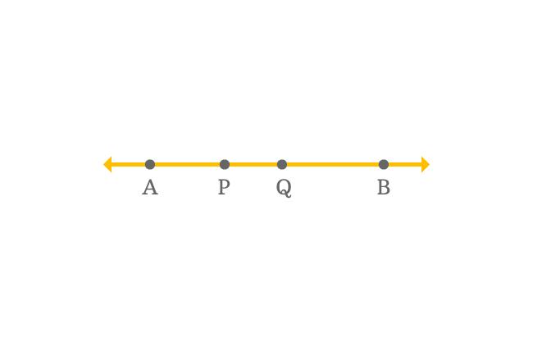
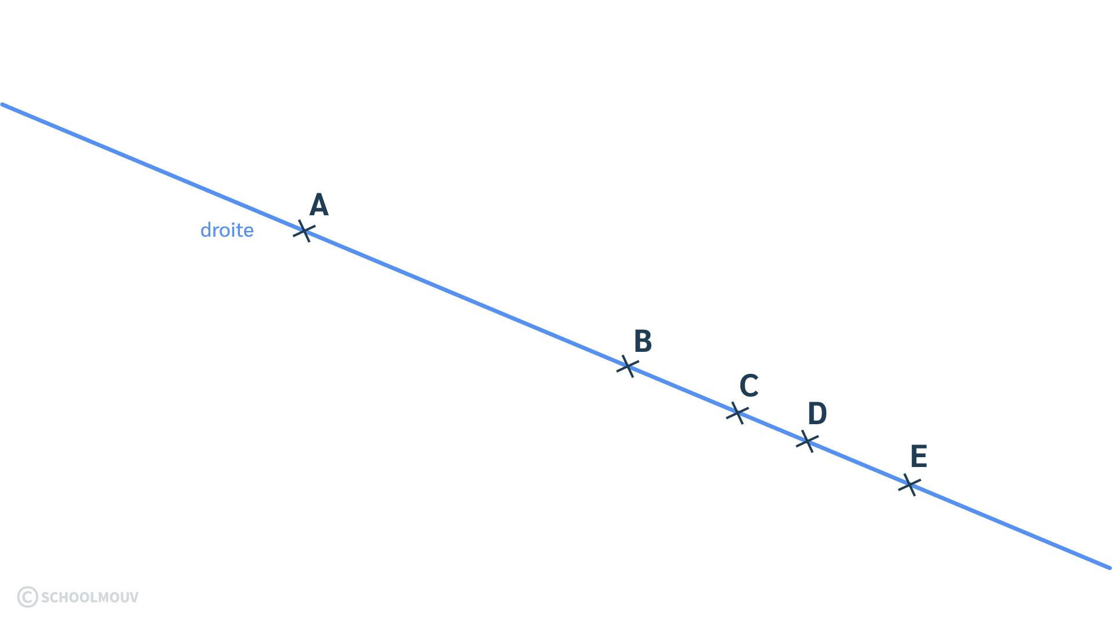
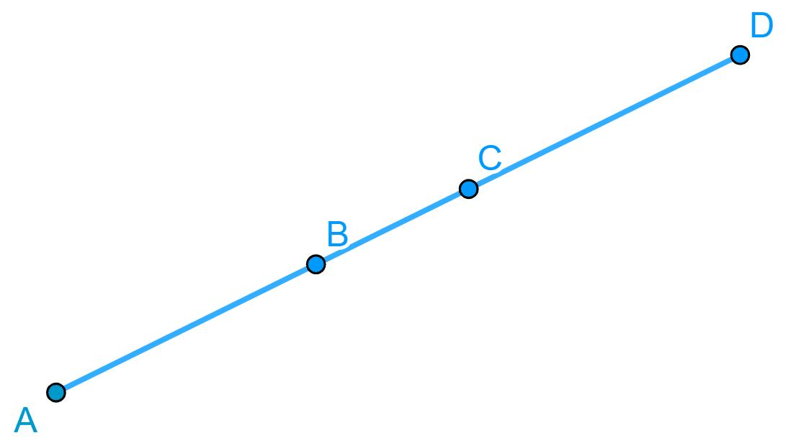
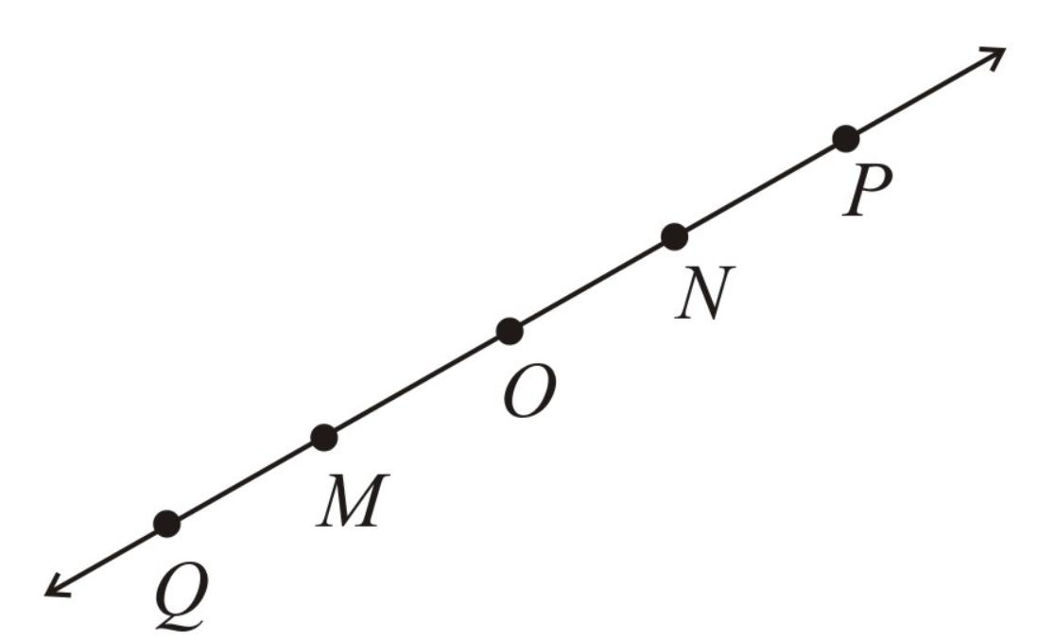
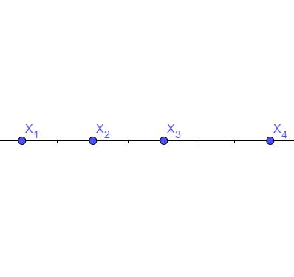
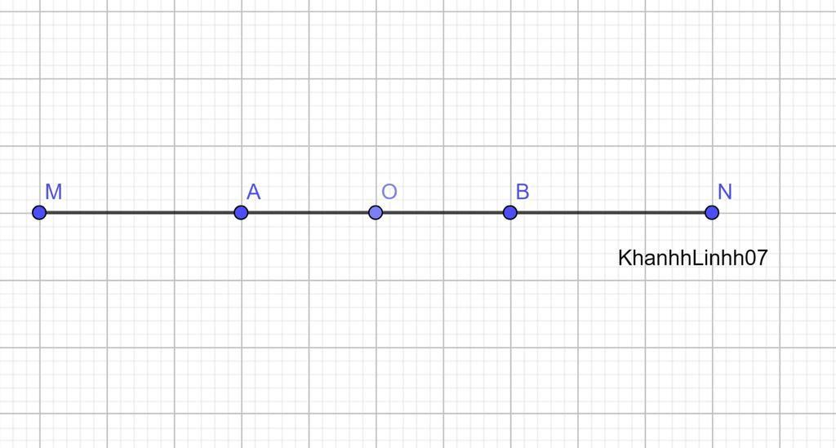

Purpose
# Source: AI Source: Provided by: [Data Path: Persons Table -> ID Column: 1, Name_En Column: Motasem Essam] -> From: [ChatGPT] on [7/25/2026]
Multi-point collinearity is used to:
- Describe the alignment of many points on one straight line.
- Identify groups of points belonging to the same line.
- Analyze complex geometric figures.
- Establish relationships between multiple line segments.
- Study coordinate geometry and point sets.
- Identify points that share a common linear equation.

Fundamental Concept
# Source: AI Source: Provided by: [Data Path: Persons Table -> ID Column: 1, Name_En Column: Motasem Essam] -> From: [ChatGPT] on [7/25/2026]
The defining condition is:
$$\boxed{P_{1},P_{2},…,P_{n}∈l}$$
for one common straight line $l$.
For example:
A ●────● B────● C────● D────● E────● F
l
All six points lie on the same straight line.
Therefore:
$$A,B,C,D,E,F$$
are multi-point collinear.

Minimum Number of Points
# Source: AI Source: Provided by: [Data Path: Persons Table -> ID Column: 1, Name_En Column: Motasem Essam] -> From: [ChatGPT] on [7/25/2026]
Multi-point collinearity requires:
$$\boxed{n≥3}$$
because:
- 2 distinct points → Two-Point Collinearity
- 3 points → Three-Point Collinearity
- 4 or more points → Multi-Point Collinearity
In a broad mathematical sense, "multi-point" can include three points, but for your taxonomy it is useful to use it specifically for larger sets of points beyond the three-point case.

Examples

Example 1 — Four Collinear Points
# Source: AI Source: Provided by: [Data Path: Persons Table -> ID Column: 1, Name_En Column: Motasem Essam] -> From: [ChatGPT] on [7/25/2026]
$$A\left(1 , 2\right), B\left(2 , 4\right), C\left(3 , 6\right), D\left(4 , 8\right)$$
All satisfy:
$$y=2x$$
Therefore:
$$\boxed{A,B,C,D\text{ are collinear}}$$

Example 2 — Five Collinear Points
# Source: AI Source: Provided by: [Data Path: Persons Table -> ID Column: 1, Name_En Column: Motasem Essam] -> From: [ChatGPT] on [7/25/2026]
Consider:
$$P_{1}\left(0 , 1\right) \\ P_{2}\left(1 , 3\right) \\ P_{3}\left(2 , 5\right) \\ P_{4}\left(3 , 7\right) \\ P_{5}\left(4 , 9\right)$$
All satisfy:
$$y=2x+1$$
Therefore:
$$\boxed{P_{1},P_{2},P_{3},P_{4},P_{5}\text{ are collinear}}$$

Testing Multi-Point Collinearity
# Source: AI Source: Provided by: [Data Path: Persons Table -> ID Column: 1, Name_En Column: Motasem Essam] -> From: [ChatGPT] on [7/25/2026]
There are several ways to establish that many points are collinear.

1. Common Line Equation
# Source: AI Source: Provided by: [Data Path: Persons Table -> ID Column: 1, Name_En Column: Motasem Essam] -> From: [ChatGPT] on [7/25/2026]
Find the equation of the line through two points:
$$y=mx+b$$
Then verify that every remaining point satisfies the same equation.
For example:
$$A\left(1 , 3\right),B\left(2 , 5\right),C\left(4 , 9\right),D\left(6 , 13\right)$$
All satisfy:
$$y=2x+1$$
Therefore all four points are collinear.

2. Equal Slope Test
# Source: AI Source: Provided by: [Data Path: Persons Table -> ID Column: 1, Name_En Column: Motasem Essam] -> From: [ChatGPT] on [7/25/2026]
Choose a reference point, such as $P_{1}$.
For every other point:
$$m_{P_{1}P_{2}}=m_{P_{1}P_{3}}=⋯=m_{P_{1}P_{n}}$$
when the slopes are defined.
Thus:
$$\boxed{m_{12}=m_{13}=⋯=m_{1n}}$$
establishes multi-point collinearity.
For vertical lines, the common $x$-coordinate can be used instead.

3. Determinant Test
# Source: AI Source: Provided by: [Data Path: Persons Table -> ID Column: 1, Name_En Column: Motasem Essam] -> From: [ChatGPT] on [7/25/2026]
Choose one reference pair, such as $P_{1}$and $P_{2}$.
Every additional point $P_{i}$must satisfy:
$$\left(x_{2}-x_{1}\right)\left(y_{i}-y_{1}\right)-\left(y_{2}-y_{1}\right)\left(x_{i}-x_{1}\right)=0$$
for:
$$i=3,4,…,n$$
Therefore:
$$\boxed{\left(x_{2}-x_{1}\right)\left(y_{i}-y_{1}\right)-\left(y_{2}-y_{1}\right)\left(x_{i}-x_{1}\right)=0}$$
for every remaining point.

Multi-Point Collinearity and Line Membership
# Source: AI Source: Provided by: [Data Path: Persons Table -> ID Column: 1, Name_En Column: Motasem Essam] -> From: [ChatGPT] on [7/25/2026]
A useful way to understand multi-point collinearity is as common line membership.
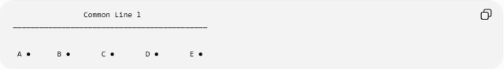
Common Line l
────────────────────────────────────────────

A ● B ● C ● D ● E ●
Mathematically:
$$A,B,C,D,E∈l$$
Each point is therefore a member of the same line.

Order of Points
# Source: AI Source: Provided by: [Data Path: Persons Table -> ID Column: 1, Name_En Column: Motasem Essam] -> From: [ChatGPT] on [7/25/2026]
Multi-point collinearity does not require the points to be listed in their geometric order.
For example, these are the same set of collinear points:
$$A,B,C,D,E$$
and:
$$D,A,E,C,B$$
The order of naming the points does not change their collinearity.
However, their spatial order along the line can be important when analyzing segments and distances.
For example:
A ●──── B ●──── C ●──── D ●──── E ●
Here:
$$AB+BC+CD+DE=AE$$

Multi-Point Collinearity and Line Segments
# Source: AI Source: Provided by: [Data Path: Persons Table -> ID Column: 1, Name_En Column: Motasem Essam] -> From: [ChatGPT] on [7/25/2026]
When several points lie on the same line, they can divide that line into multiple line segments.
For:
A ●──── B ●──── C ●──── D ●
the points generate segments such as:
$$\overset{‾}{AB}, \overset{‾}{BC}, \overset{‾}{CD}$$
and larger segments:
$$\overset{‾}{AC}, \overset{‾}{BD}, \overset{‾}{AD}$$
Thus, multi-point collinearity provides the basis for studying multiple collinear line segments.

Multi-Point Collinearity vs. Three-Point Collinearity
# Source: AI Source: Provided by: [Data Path: Persons Table -> ID Column: 1, Name_En Column: Motasem Essam] -> From: [ChatGPT] on [7/25/2026]
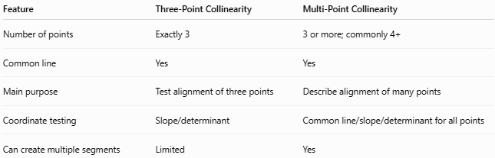
Feature | Three-Point Collinearity | Multi-Point Collinearity
Number of points | Exactly 3 | 3 or more; commonly 4+
Common line | Yes | Yes
Main purpose | Test alignment of three points | Describe alignment of many points
Coordinate testing | Slope/determinant | Common line/slope/determinant for all points
Can create multiple segments | Limited | Yes
For a clean knowledge-base taxonomy, it is useful to distinguish them as:
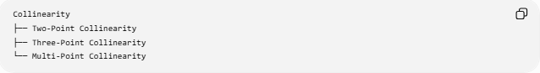
Collinearity
├── Two-Point Collinearity
├── Three-Point Collinearity
└── Multi-Point Collinearity
with Multi-Point Collinearity emphasizing larger sets of aligned points.

Multi-Point Collinearity vs. Non-Collinear Point Sets
# Source: AI Source: Provided by: [Data Path: Persons Table -> ID Column: 1, Name_En Column: Motasem Essam] -> From: [ChatGPT] on [7/25/2026]
Collinear set
$$P_{1},P_{2},P_{3},P_{4},P_{5}∈l$$
All points share one line.
Non-collinear set
At least one point does not belong to the common line:
$$P_{k}∉l$$
Therefore the entire set is not collinear.
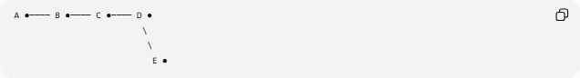
A ●──── B ●──── C ●──── D ●
\
\
E ●
Here $A,B,C,D$are collinear, but $E$is not on their common line.

Important Property: Subsets
# Source: AI Source: Provided by: [Data Path: Persons Table -> ID Column: 1, Name_En Column: Motasem Essam] -> From: [ChatGPT] on [7/25/2026]
A particularly useful property is that every subset of a collinear point set is also collinear.
If:
$$P_{1},P_{2},P_{3},P_{4},P_{5}∈l$$
then:
$$P_{1},P_{3},P_{5}∈l$$
and:
$$P_{2},P_{4}∈l$$
Therefore, any selection of the points remains on the same line.

Applications
# Source: AI Source: Provided by: [Data Path: Persons Table -> ID Column: 1, Name_En Column: Motasem Essam] -> From: [ChatGPT] on [7/25/2026]
Geometry
Used to describe multiple points aligned along a geometric construction.
Coordinate Geometry
Used to identify sets of points satisfying one linear equation:
$$y=mx+b$$
Computer Graphics
Used when multiple points form a straight geometric edge or path.
Surveying
Points measured along a straight boundary or reference line can be checked for collinearity.
Engineering
Reference points along a straight edge, axis, or structural element can be analyzed for alignment.

Key Points
# Source: AI Source: Provided by: [Data Path: Persons Table -> ID Column: 1, Name_En Column: Motasem Essam] -> From: [ChatGPT] on [7/25/2026]
- Multi-point collinearity involves three or more points lying on one straight line.
- All points must belong to the same supporting line.
- The points do not have to be adjacent.
- The order in which points are named does not affect collinearity.
- A common line equation can be used to verify all points.
- Equal slopes can establish collinearity when applicable.
- The determinant test can be applied to each additional point.
- Every subset of a collinear point set is also collinear.
- Multiple collinear points can divide a line into many segments.
- Multi-point collinearity is especially useful in coordinate geometry and geometric constructions.

Conclusion
# Source: AI Source: Provided by: [Data Path: Persons Table -> ID Column: 1, Name_En Column: Motasem Essam] -> From: [ChatGPT] on [7/25/2026]
Multi-Point Collinearity describes the alignment of multiple points on a single straight line. It extends the concept of three-point collinearity to larger sets of points and provides an important foundation for studying line membership, multiple line segments, coordinate geometry, and geometric alignment.

